Example 1: 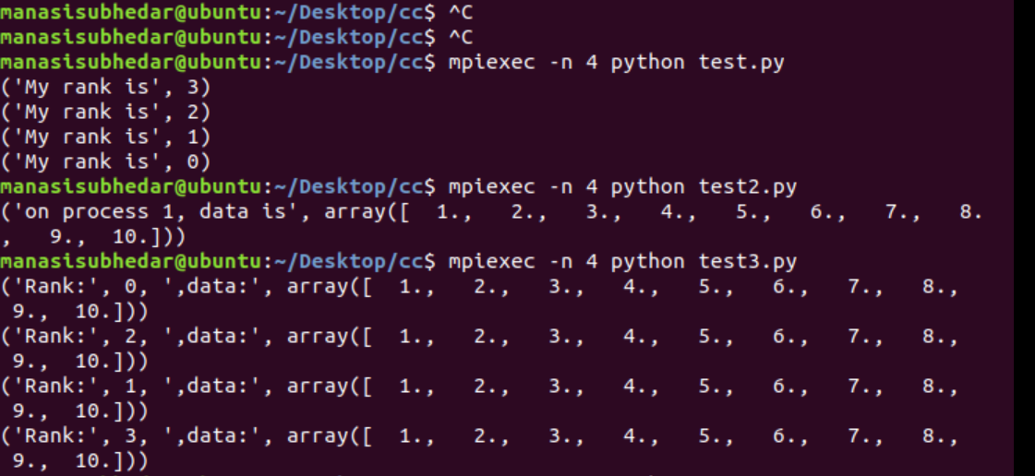

Example 2:



Example 3:



Example 4:

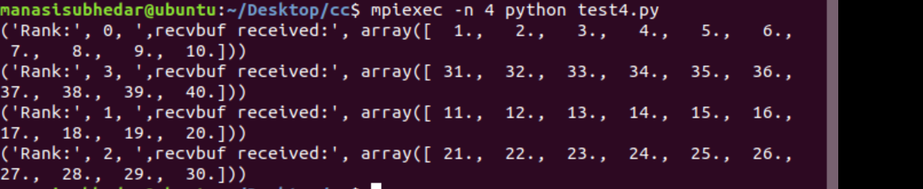

Example 5:

